import pandas as pd
import numpy as np
import seaborn as sns
import matplotlib.pyplot as plt
import warnings
warnings.filterwarnings(action="ignore")
from sklearn.model_selection import train_test_split
from sklearn.metrics import accuracy_score, classification_report
from sklearn.svm import SVC
from imblearn.over_sampling import SMOTE
from sklearn.ensemble import AdaBoostClassifier
from sklearn.metrics import roc_curve, auc
from sklearn import metrics
from sklearn.metrics import confusion_matrix
from sklearn.datasets import make_classification
from sklearn.metrics import accuracy_score, precision_score, recall_score, f1_score
C:\Users\agarw\anaconda3\lib\site-packages\scipy\__init__.py:146: UserWarning: A NumPy version >=1.16.5 and <1.23.0 is required for this version of SciPy (detected version 1.26.2
warnings.warn(f"A NumPy version >={np_minversion} and <{np_maxversion}"
#importing data from the dataset
df = pd.read_csv(r"C:\Users\agarw\OneDrive\Desktop\Dissertation\data.csv")
#checking for bankrupt companies 0 is non-bankrupt and 1 is bankrupt
bankrupt_data = df['Bankrupt?'].value_counts()
bankrupt_data
Bankrupt?
0 6599
1 220
Name: count, dtype: int64
#Distribution representation
plt.figure(figsize = (10,5))
colors = ["#3498db", "#e74c3c"]
ax = sns.countplot(x=df['Bankrupt?'], data=df,palette=colors)
for p in ax.patches:
ax.annotate(f'{p.get_height()}', (p.get_x() + p.get_width() / 2., p.get_height()),
ha='center', va='center', xytext=(0, 10), textcoords='offset points')
# Add labels and title
plt.xlabel('Bankrupt')
plt.ylabel('Count')
plt.title('Distribution of Bankrupt')
# Show the plot
plt.show()
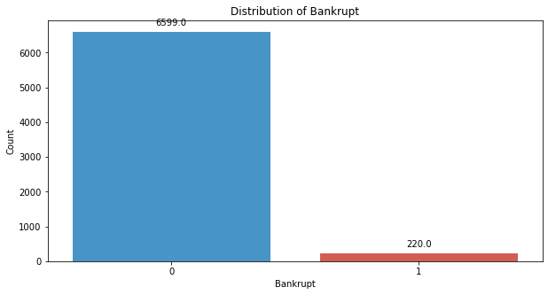
# seperate the Bankrupt label from the dataset
y = df['Bankrupt?']
X = df.drop(['Bankrupt?'], axis = 1)
# divinding our dataset into training dataset
X_train, X_temp, y_train, y_temp = train_test_split(X, y, test_size=0.2, random_state=42)
#Distribution representation
plt.figure(figsize = (10,5))
colors = ["#3498db", "#e74c3c"]
ax = sns.countplot(x=y_train, data=df,palette=colors)
for p in ax.patches:
ax.annotate(f'{p.get_height()}', (p.get_x() + p.get_width() / 2., p.get_height()),
ha='center', va='center', xytext=(0, 10), textcoords='offset points')
# Add labels and title
plt.xlabel('Bankrupt')
plt.ylabel('Count')
plt.title('Distribution of Bankrupt')
# Show the plot
plt.show()
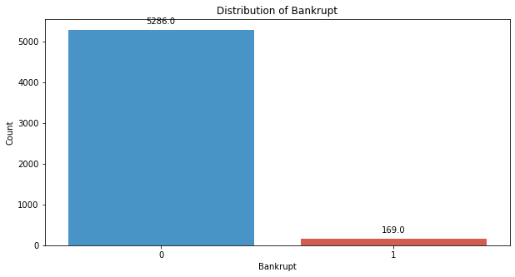
# divinding our dataset into testing and validation
X_val, X_test, y_val, y_test = train_test_split(X_temp, y_temp, test_size=0.5, random_state=42)
smote = SMOTE(sampling_strategy=0.25,random_state=42)
X_train_resampled, y_train_resampled = smote.fit_resample(X_train, y_train)
#Distribution representation
plt.figure(figsize = (10,5))
colors = ["#3498db", "#e74c3c"]
ax = sns.countplot(x=y_train_resampled, data=df,palette=colors)
for p in ax.patches:
ax.annotate(f'{p.get_height()}', (p.get_x() + p.get_width() / 2., p.get_height()),
ha='center', va='center', xytext=(0, 10), textcoords='offset points')
# Add labels and title
plt.xlabel('Bankrupt')
plt.ylabel('Count')
plt.title('Distribution of Bankrupt')
# Show the plot
plt.show()
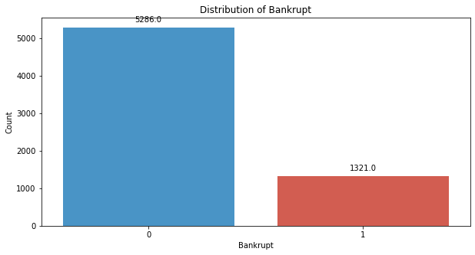
svm_classifier_poly = SVC(kernel='poly', random_state=42)
svm_classifier_poly.fit(X_train_resampled, y_train_resampled)
SVC(kernel='poly', random_state=42)
y_val_pred_poly = svm_classifier_poly.predict(X_val)
# Evaluate the model's performance on the validation set
val_accuracy = accuracy_score(y_val, y_val_pred_poly)
precision = precision_score(y_val, y_val_pred_poly)
recall = recall_score(y_val, y_val_pred_poly)
f1_value = f1_score(y_val, y_val_pred_poly)
val_report = classification_report(y_val, y_val_pred_poly)
print("Accuracy", val_accuracy)
print("Precision", precision)
print("Recall", recall)
print("F1 Score", f1_value)
print("Validation Classification Report:\n", val_report)
Accuracy 0.9633431085043989
Precision 0.14285714285714285
Recall 0.05
F1 Score 0.07407407407407408
Validation Classification Report:
precision recall f1-score support
0 0.97 0.99 0.98 662
1 0.14 0.05 0.07 20
accuracy 0.96 682
macro avg 0.56 0.52 0.53 682
weighted avg 0.95 0.96 0.95 682
conf_matrix = confusion_matrix(y_val, y_val_pred_poly)
print("Confusion Matrix")
print(conf_matrix)
Confusion Matrix
[[656 6]
[ 19 1]]
y_test_pred_poly = svm_classifier_poly.predict(X_test)
# Evaluate the model's performance on the test set
test_accuracy = accuracy_score(y_test, y_test_pred_poly)
precision = precision_score(y_test, y_test_pred_poly)
recall = recall_score(y_test, y_test_pred_poly)
f1_value = f1_score(y_test, y_test_pred_poly)
test_report = classification_report(y_test, y_test_pred_poly)
print("Accuracy", test_accuracy)
print("Precision", precision)
print("Recall", recall)
print("F1 Score", f1_value)
print("Test Classification Report:\n", test_report)
Accuracy 0.9457478005865103
Precision 0.0
Recall 0.0
F1 Score 0.0
Test Classification Report:
precision recall f1-score support
0 0.95 0.99 0.97 651
1 0.00 0.00 0.00 31
accuracy 0.95 682
macro avg 0.48 0.50 0.49 682
weighted avg 0.91 0.95 0.93 682
conf_matrix = confusion_matrix(y_test, y_test_pred_poly)
print("Confusion Matrix")
print(conf_matrix)
Confusion Matrix
[[645 6]
[ 31 0]]
# Compute ROC curve and ROC area for each class
fpr_val, tpr_val, _ = roc_curve(y_val, y_val_pred_poly)
roc_auc_val = auc(fpr_val, tpr_val)
fpr_test, tpr_test, _ = roc_curve(y_test, y_test_pred_poly)
roc_auc_test = auc(fpr_test, tpr_test)
# Plot ROC curve
plt.figure(figsize=(8, 8))
plt.plot(fpr_val, tpr_val, color='darkorange', lw=2, label=f'Validation ROC curve (area = {roc_auc_val:.2f})')
plt.plot(fpr_test, tpr_test, color='green', lw=2, label=f'Test ROC curve (area = {roc_auc_test:.2f})')
plt.plot([0, 1], [0, 1], color='navy', lw=2, linestyle='--')
plt.xlim([0.0, 1.0])
plt.ylim([0.0, 1.05])
plt.xlabel('False Positive Rate')
plt.ylabel('True Positive Rate')
plt.title('Receiver Operating Characteristic (ROC) Curve')
plt.legend(loc="lower right")
plt.show()
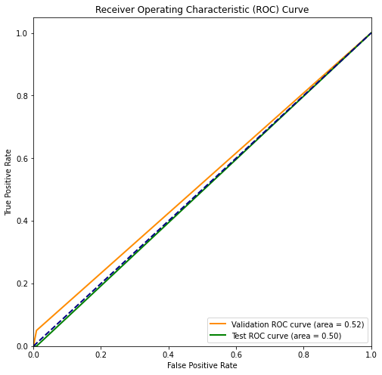
svm_classifier_rbf = SVC(kernel='rbf', random_state=42,gamma='auto')
svm_classifier_rbf.fit(X_train_resampled, y_train_resampled)
SVC(gamma='auto', random_state=42)
y_val_pred_rbf = svm_classifier_rbf.predict(X_val)
# Evaluate the model's performance on the validation set
val_accuracy = accuracy_score(y_val, y_val_pred_rbf)
precision = precision_score(y_val, y_val_pred_rbf)
recall = recall_score(y_val, y_val_pred_rbf)
f1_value = f1_score(y_val, y_val_pred_rbf)
val_report = classification_report(y_val, y_val_pred_rbf)
print("Accuracy", val_accuracy)
print("Precision", precision)
print("Recall", recall)
print("F1 Score", f1_value)
print("Validation Classification Report:\n", val_report)
Accuracy 0.9706744868035191
Precision 0.0
Recall 0.0
F1 Score 0.0
Validation Classification Report:
precision recall f1-score support
0 0.97 1.00 0.99 662
1 0.00 0.00 0.00 20
accuracy 0.97 682
macro avg 0.49 0.50 0.49 682
weighted avg 0.94 0.97 0.96 682
conf_matrix = confusion_matrix(y_val, y_val_pred_rbf)
print("Confusion Matrix")
print(conf_matrix)
Confusion Matrix
[[662 0]
[ 20 0]]
y_test_pred_rbf = svm_classifier_rbf.predict(X_test)
# Evaluate the model's performance on the test set
test_accuracy = accuracy_score(y_test, y_test_pred_rbf)
precision = precision_score(y_test, y_test_pred_rbf)
recall = recall_score(y_test, y_test_pred_rbf)
f1_value = f1_score(y_test, y_test_pred_rbf)
test_report = classification_report(y_test, y_test_pred_rbf)
print("Accuracy", test_accuracy)
print("Precision", precision)
print("Recall", recall)
print("F1 Score", f1_value)
print("Test Classification Report:\n", test_report)
Accuracy 0.9545454545454546
Precision 0.0
Recall 0.0
F1 Score 0.0
Test Classification Report:
precision recall f1-score support
0 0.95 1.00 0.98 651
1 0.00 0.00 0.00 31
accuracy 0.95 682
macro avg 0.48 0.50 0.49 682
weighted avg 0.91 0.95 0.93 682
conf_matrix = confusion_matrix(y_test, y_test_pred_rbf)
print("Confusion Matrix")
print(conf_matrix)
Confusion Matrix
[[651 0]
[ 31 0]]
# Compute ROC curve and ROC area for each class
fpr_val, tpr_val, _ = roc_curve(y_val, y_val_pred_rbf)
roc_auc_val = auc(fpr_val, tpr_val)
fpr_test, tpr_test, _ = roc_curve(y_test, y_test_pred_rbf)
roc_auc_test = auc(fpr_test, tpr_test)
# Plot ROC curve
plt.figure(figsize=(8, 8))
plt.plot(fpr_val, tpr_val, color='darkorange', lw=2, label=f'Validation ROC curve (area = {roc_auc_val:.2f})')
plt.plot(fpr_test, tpr_test, color='green', lw=2, label=f'Test ROC curve (area = {roc_auc_test:.2f})')
plt.plot([0, 1], [0, 1], color='navy', lw=2, linestyle='--')
plt.xlim([0.0, 1.0])
plt.ylim([0.0, 1.05])
plt.xlabel('False Positive Rate')
plt.ylabel('True Positive Rate')
plt.title('Receiver Operating Characteristic (ROC) Curve')
plt.legend(loc="lower right")
plt.show()
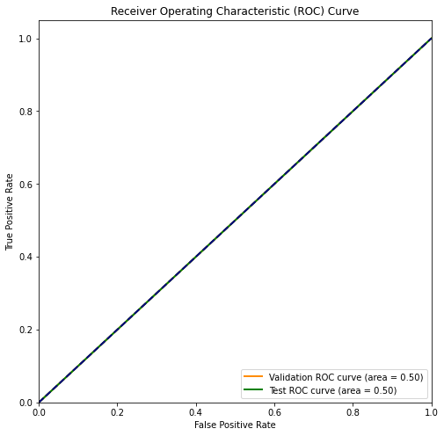
svm_classifier_sigmoid = SVC(kernel='sigmoid', random_state=42,gamma='auto')
svm_classifier_sigmoid.fit(X_train_resampled, y_train_resampled)
SVC(gamma='auto', kernel='sigmoid', random_state=42)
y_val_pred_sigmoid = svm_classifier_sigmoid.predict(X_val)
# Evaluate the model's performance on the validation set
val_accuracy = accuracy_score(y_val, y_val_pred_sigmoid)
precision = precision_score(y_val, y_val_pred_sigmoid)
recall = recall_score(y_val, y_val_pred_sigmoid)
f1_value = f1_score(y_val, y_val_pred_sigmoid)
val_report = classification_report(y_val, y_val_pred_sigmoid)
print("Accuracy", val_accuracy)
print("Precision", precision)
print("Recall", recall)
print("F1 Score", f1_value)
print("Validation Classification Report:\n", val_report)
Accuracy 0.9398826979472141
Precision 0.0
Recall 0.0
F1 Score 0.0
Validation Classification Report:
precision recall f1-score support
0 0.97 0.97 0.97 662
1 0.00 0.00 0.00 20
accuracy 0.94 682
macro avg 0.48 0.48 0.48 682
weighted avg 0.94 0.94 0.94 682
conf_matrix = confusion_matrix(y_val, y_val_pred_sigmoid)
print("Confusion Matrix")
print(conf_matrix)
Confusion Matrix
[[641 21]
[ 20 0]]
y_test_pred_sigmoid = svm_classifier_sigmoid.predict(X_test)
# Evaluate the model's performance on the test set
test_accuracy = accuracy_score(y_test, y_test_pred_sigmoid)
precision = precision_score(y_test, y_test_pred_sigmoid)
recall = recall_score(y_test, y_test_pred_sigmoid)
f1_value = f1_score(y_test, y_test_pred_sigmoid)
test_report = classification_report(y_test, y_test_pred_sigmoid)
print("Accuracy", test_accuracy)
print("Precision", precision)
print("Recall", recall)
print("F1 Score", f1_value)
print("Test Classification Report:\n", test_report)
Accuracy 0.9428152492668622
Precision 0.0
Recall 0.0
F1 Score 0.0
Test Classification Report:
precision recall f1-score support
0 0.95 0.99 0.97 651
1 0.00 0.00 0.00 31
accuracy 0.94 682
macro avg 0.48 0.49 0.49 682
weighted avg 0.91 0.94 0.93 682
conf_matrix = confusion_matrix(y_test, y_test_pred_sigmoid)
print("Confusion Matrix")
print(conf_matrix)
Confusion Matrix
[[643 8]
[ 31 0]]
# Compute ROC curve and ROC area for each class
fpr_val, tpr_val, _ = roc_curve(y_val, y_val_pred_sigmoid)
roc_auc_val = auc(fpr_val, tpr_val)
fpr_test, tpr_test, _ = roc_curve(y_test, y_test_pred_sigmoid)
roc_auc_test = auc(fpr_test, tpr_test)
# Plot ROC curve
plt.figure(figsize=(8, 8))
plt.plot(fpr_val, tpr_val, color='darkorange', lw=2, label=f'Validation ROC curve (area = {roc_auc_val:.2f})')
plt.plot(fpr_test, tpr_test, color='green', lw=2, label=f'Test ROC curve (area = {roc_auc_test:.2f})')
plt.plot([0, 1], [0, 1], color='navy', lw=2, linestyle='--')
plt.xlim([0.0, 1.0])
plt.ylim([0.0, 1.05])
plt.xlabel('False Positive Rate')
plt.ylabel('True Positive Rate')
plt.title('Receiver Operating Characteristic (ROC) Curve')
plt.legend(loc="lower right")
plt.show()
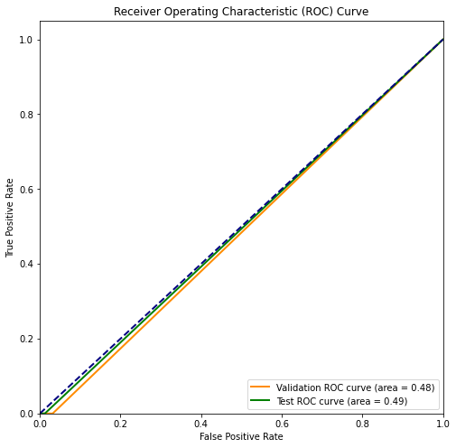
svm_classifier_linear = SVC(kernel='linear', random_state=42)

